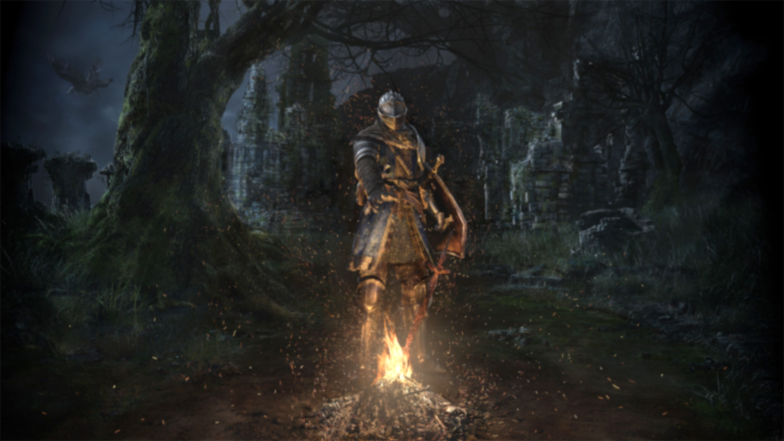
Written by T.F. Baas
Tom.baas@live.nl
Dark souls: Character research
What play experience does the character enforce?
Introduction
I am currently making a character controller based / inspired by the original dark souls, Dark Souls 1. I will be hand-keying all the animations required for the controller on a custom-made rig.

Since I will be making a character controller based on dark souls, it is good to research exactly what player experience they enforce with their character and how they achieved this.

Research Question:
What play experience does the dark souls character enforce?

To narrow and scope down the research, I will look at dark souls through the lens of a standard combat encounter, using melee weapons and a single enemy

Topics:
- Attacking
- Rolling
- Stamina
- Camera
- Gear
- Conclusion
- Take-aways

Attacking
The player in dark souls has multiple ways to deal damage. some are conditional, Counters, Backstabs & Plunges. but I will not address them in this document due to them being an entirely different beast.

Range & Sticking
One thing that makes dark souls stand out from the rest, is that it has no “sticking”, that games like God of war & Batman: Arkham series experience. You can freely miss attacks and it will punish the player for it. This adds another dimension to the combat and rewards those that strike with accuracy. It gives the players a reason to play with spears & pikes, or a reason not to play with short weapons like daggers.

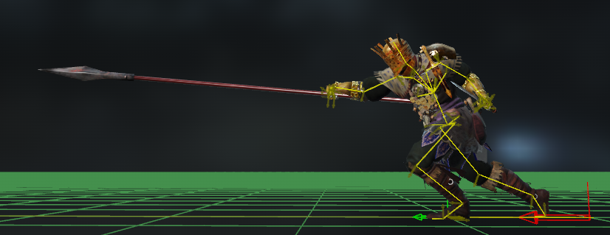
Figure 1: Player character doing a one-handed stab with a pike.
Controls & Attack types
Attack Type | Description | Gamepad | PC
Light attack | Quick, standard attack. | Right-bumper | Left-click
Heavy attack | Slow, High damage attack. | Right-trigger | Right-click
Jump attack | Forward jumping attack, high damage. | Flick left stick + right-trigger | Tap W/A/S/D + right-click
Running attack | Quick attack from running (and backstep) | Run or backstep + right-bumper | Run or Backstep + left-click
Rolling attack | Quick attack after rolling. | Right-bumper after roll | Left-click after roll.
Kick | Kick, breaking blocks. | Flick let stick + right-bumper. | Tap W/A/S/D + left-click
Note that PC controls might differ between Dark souls 1 & Dark souls remastered.
Dark souls has five different attacks, each with their own animations corresponding to their weapons. The move set changes depending on the weapon the character is wielding but the purpose vaguely remains the same.

Attack frame Data
Using a program called DSAnimstudio I was able to gain insight in how the states of the attacks and other notifies are handled. I will use the ultra greatsword animations as the data point and look only at them.

I've divided the animations in 4 different sections. Start, Trace, Recovery and Blend out. I've differed from the original Windup, Release, and recovery sections due to it not mentioning the part of the animation where it detects hits, which I think is important.

Windup is where the animation will start and lock the character in place, while charging up the swing. Trace is the part of the animation where the actual hit detection will take place. Recovery is the amount of time after the Trace, where the player is stuck in place and vulnerable to attack while winding down from the impact. Blend out is the part in the animation where the animation will return to idle, but the player is free to move.

Frames per state | Light attack | Heavy attack | Jump attack | Running attack | Rolling attack | Kick
Windup | 23 | 30 | 30 | 21 | 17 | 13
Hit Detection | 5 | 3 | 4 | 4 | 4 | 4
Recovery | 23 | 35 | 29 | 35 | 19 | 14
To Idle | 32 | 41 | 22 | 29 | 31 | 19
Total | 83 | 107 | 85 | 89 | 71 | 50

An interesting thing to note about these animations is that the trace of every attack is between 3-5 frames. This doesn’t sound like anything, but the fact that the average animation (without a blend to idle) is around 50-60 frames long, makes it quite interesting in comparison. This means that on average the trace phase of an attack makes up around 6-8% of the animation.

- Light attack
Light attacks are the bread and butter of dark souls’ combat, it is the “basic attack” if you will. It has a fairly low amount of windup frames and deals a moderate amount of damage. You’re able to combo light attacks and mix them up with heavy attacks vice versa.

- Heavy attack
Heavy attacks are the most specialized attacks and often have unique animations and effects depending on the weapon. They are the slowest attacks in the game and also deal the largest amounts of damage. They can combo from light and other heavy attacks.

Compared to the light attacks the heavy attack needs an extra 15 frames to get out of recovery, this is half a second extra. This has a tremendous effect on the feeling of the attack.

- Jump attack
The jump attack is in my opinion a little underrated. It does similar damage to a heavy attack but is just slightly faster and has a forwards hop. However, it cannot be combo’d and requires a more finicky input, having to flick left stick forward and press right-trigger at the same time. This results in the attack being less readily available and adding a small skill-check on it. This in turn, makes it used much less frequently than all the other attacks.

- Running attack
The running attack can only be performed out of a running state, or a backstep. It does similar damage to a light attack and has the character dashing forward. This is my favorite attack in the game due to it acting like a counter-attack after a successful backstep.

- Rolling attack
The rolling attack is the quickest damage dealing attack in the game, having only 17 windup frames. It deals similar damage to a light attack and is also the most forgiving attack in the game having only 14 frames of recovery. This is the go-to attack when it comes to dark souls builds relying on heavier weapons.

- Kick
The kick attack is a heavily specialized attack that only gets used in specific scenarios. Nonetheless is a key marker of the players’ understanding of the game if they use the kick in the right scenario.

The kick breaks blocks, it is best (and should only be) used on enemies that have shields and that “turtle” behind it. After it breaks a block, the player can successfully perform a counter on them.
Turning the swing
Figure 2: Player character turns his swing mid-windup.
While doing dissecting the animations in the DSAnimstudio I noticed something I that I never paid attention to. Start of animation turning. There was a “disable turning” notify in the animation and after trying it out in-game I noticed that dark souls allows for turning the direction of the swing only in limited parts of said swing, usually in the middle or start of a wind-up.

This is interesting, since it is a pretty impactful feature that I somehow never knew even existed.

 | Light attack | Heavy attack | Jump attack | Running attack | Rolling attack | Kick
Frames able to turn | 13-19  6 frames total | 2-7  5 frames total | 0-6  6 frames total | 0-6  6 frames total | 5-11  6 frames total | 0-7  7 frames total
Minor Swing tilt
One thing that dark souls does that probably no one has ever noticed, is that dark souls slightly tilts your swing up or down depending on where you are looking.

I’m not sure exactly what the purpose of this was, but I can imagine it helping the player aim at the center of mass of larger bosses when It takes the camera lock on into account.

No attack canceling
Figure 3: Player character adjusts the direction of the swing by looking down, hitting the floor.
Dark souls has no attack canceling whatsoever. This means that the character is fully locked into every attack that he performs. This is why the frame data is really important, our character doing a light attack is locked in place for the full duration of 51 frames, which is 1.7 seconds. There are absolutely no exceptions to this except for receiving a hit. This is an important characteristic of the dark souls 1 combat.

Light attack frame analysis
I’ve made a small sketch of what the track of an attack could look like.
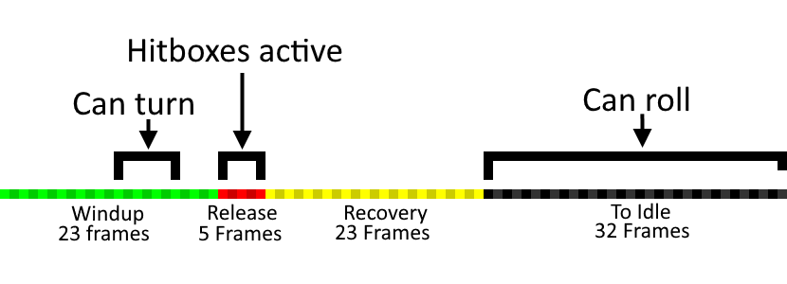

Figure 4: sketched animation track of the ultra greatsword light attack.
Rolling
The most powerful tool the player has at his disposal is the roll. The roll costs stamina but gives frames of invincibility & a dash in return. It is the core mechanic to what dark souls is built around.

The roll is also affected by how much the player is carrying in weight. This makes players want to wear lighter gear when using large and heavy weapons due to wanting to have a “fast roll”. This is because the number of I-frames (Invincibility frames) change depending on what type of roll the player has. This is also why gear plays a big roll in how a character plays and feels. More on that in the gear Section.

Encumbrance |  | Rolling
From | To | I-Frames | Total Frames | Roll animation
0% |  | 13 | 21 | Fast Roll.
0.1% | 8.3% | 13 | 22
8.4% | 16.6% | 13 | 23
16.7% | 25% | 13 | 24
25% | 33.3% | 11 | 33 | Mid Roll.
33.4% | 41.6% | 11 | 33
41.7% | 50% | 11 | 33
50.1% | 100% | 9 | 46 | Fat Roll.
100% < |  | Can’t roll anymore. |  | None.

Figure 5: The player effectively times his roll and successfully evades the enemies’ attacks

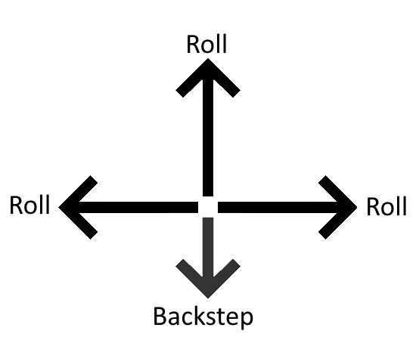
The I-frames the players gets from rolling are activated instantly. This requires the player to patiently for the right time during an enemy attack until you’re able to effectively roll. If you roll to early & if you roll too late, you get hit. You need to roll at almost exactly the right time. This adds a layer of timing and rhythm to dark souls.

Rolling direction
When going into the animations of dark souls 1 I’ve found animations for all directions of dodges. But when going into the game, the dodges are only on the forward, left & right direction. The backwards dodge is replaced by a backstep in game. However, some NPC’s do use the backwards dodge animations. So, the dodge directions look something like figure 6.
Figure 6: All the possible directions of dodges. This is rotated by the character rotation.

The input direction of rolling is always clamped to these directions, with the only thing rotating these directions being the character itself. With these clamped directions and the input direction being parented to the camera, it makes for a mis-match in direction and can at time roll the player in a direction that he didn’t intend. I think this makes a big deal in the feeling of the game and can result into the game being called “clunky”.
Figure 7: Succeeding in rolling in an un-intended direction while attempting to roll backwards.

Blocking
Dark souls has the ability to block with any weapon and any shield. As long as the shield in the left hand, or as long as the weapon is being held with two hands. Different weapons & shields have different damage mitigations when blocking, but overall, the shields are obviously the most effective. However, ultra-great swords are also surprisingly effective coming in at 70% physical damage mitigation.

Effectively blocking an enemy’s hit will drain stamina and knock you back very slightly. If no stamina is left and the player blocked a hit, he will be guard-broken, leaving him open for attack (and a possible counter). Shields can deflect attacks if the shield stat stability is high enough for the given attack. This will reduce the stamina drain and make the enemies bounce back upon a hit.

Some attacks drain too much stamina to even be blocked, and other attacks are simply unblockable. Players have access to this too. For example, the shotel weapon heavy attack is meant to hit straight through shields.

Figure 8: Player successfully blocks the enemies heavy attack and deflects the light attacks.
Stamina
The mechanic that grounds all the other mechanics in dark souls is the stamina bar. If you don’t have stamina, you can’t perform any moves. However, without the mechanic, you could block & attack infinitely. A lot of challenges in this game would become trivial.

Stamina scales on the endurance stat and the player can put a maximum of 40 points in it before reaching the hard cap.

Endurance | 08 | 09 | 10 | 11 | 12 | 13 | 14 | 15 | 16 | 17 | 18 | 19 | 20 | 21 | 22 | 23 | 24
Stamina | 89 | 90 | 91 | 93 | 95 | 97 | 98 | 100 | 102 | 104 | 106 | 108 | 110 | 112 | 115 | 117 | 119
Endurance | 25 | 26 | 27 | 28 | 29 | 30 | 31 | 32 | 33 | 34 | 35 | 36 | 37 | 38 | 39 | 40 | 41
Stamina | 121 | 124 | 126 | 129 | 131 | 133 | 136 | 139 | 141 | 144 | 146 | 149 | 152 | 154 | 157 | 160 | 160
I’ve pulled this data from a PDF found on the DS1 wiki.
The minimum amount of stamina that the player can have is 89 and the maximum is 160. The standard amount of stamina regen that the player has is 45 stamina per second. This is able to be boosted by a number of items. Wearing heavy armor also has an effect on stamina consumption and can reduce the stamina regen by -5 if wearing a total set. Holding block reduces stamina regen stamina by around -80% after all the armor & encumbrance de-buffs.

Consumption
Attacking, blocking attacks, running, jumping, rolling, parrying, backstepping and countering will consume stamina. Heavy attacks consume more stamina than light attacks, and two-handing a weapon will also increase the amount of stamina consumed. You can still attack even if you don’t have the full amount of stamina required, however the interesting thing about this is that it is possible to reach a negative amount of stamina. You can have up to a minimum of -50 negative stamina. It is not possible to perform any actions that cost stamina until your stamina has gone back up to positive.

Camera
by far the most important part of the DS1 camera is that it can lock-on to enemies. This changes the movement animations and forces the target to always be in the screen. However, it doesn’t attempt to keep the enemy in the center of the screen. It allows for the enemy to move around and still take up different spots in the screen, fitting into the rule of thirds. This adds a lot of visual flair when it comes to boss fights and I my opinion makes them look significantly better.
Figure 9: The camera tries to keep the player in the center and fitting the boss onto the screen. Fitting the rule of 3rds.
This applies to enemies of any size. Even with the small enemies like skeletons. The camera will always have the enemies center of mass as the target for the lock-on. However, I think all of these center of mass points are man-made.
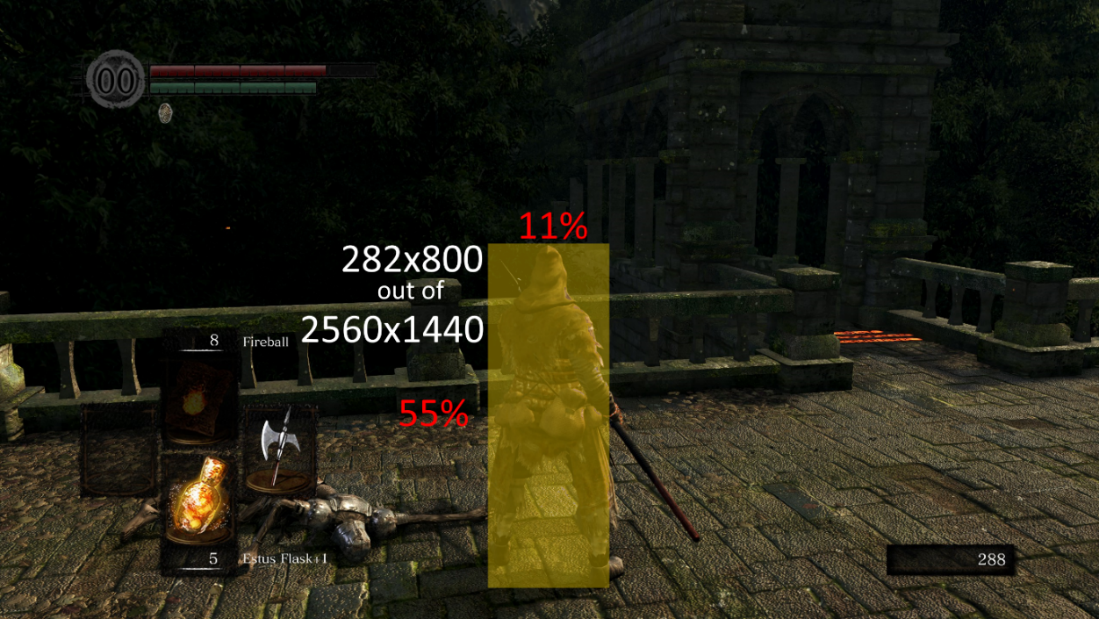
The player character takes up a big chunk of the screen space. Noticeably more than its successor Dark souls 3. The dark souls 1 camera also doesn’t have the ability to zoom out. And will mostly stick to this screen ratio. The camera does zoom in if the camera detects collision it will attempt to get close to fix this.
Figure 10: Camera follows the character and rotates to make sure he stays in the screen space.
Figure 11: Character to screen ratio analysis

The camera follows and moves with the character. This is very alike old platformers and makes playing with a controller much better.

Another thing to note on the camera, is that when there is a lock on, and you move left and right, the character starts strafing while looking at the locked-on target.

Gear
Dark souls is an RPG, this means that the game will also contain some type of progression. To cover this, it has leveling and gear. Gear doesn’t give any stats unless it’s a unique weapon / gear piece. This is great because it allows for unique playstyles based on what stats you’re leveling and what gear the player is wearing. This is core to the dark souls experience, and it allows for an immense amount of replay-ability. It allows you to play the game in a completely different way every time you start over. You can use a dexterity build, strength build, sorcerer build, faith build, hybrid build etc…

In melee weapons the main stat that will have an effect on player experience is the weapon’s attack speed. this game has weapons that are hugely different. Someone on reddit made an excel sheet and data mined all attack speeds in the game. the values seem about right but take it with a grain of salt since it’s from a reddit post.

In this excel sheet you can look at all the attacks per second for each weapon and spot the slowest and fastest weapons in the game. Smough’s Hammer comes first as slowest weapon in the game with 0.62^{[4]} two-handed light attacks per second. The standard dagger comes in as fastest weapon in the game with 2.22^{[4]} two-handed light attacks per second. This is a 1.6 second difference.

The excel sheet also features damage per second, however a lot of the data is lacking. So, I can’t make any assumptions on it.

The gameplay will widely differ depending on what weapon is used and will hugely impact how the game feels like.

Conclusion
The Dark souls character wants the player to be deliberate, conscious, and careful.

Attacks are slow and heavy, have long windups & long recoveries with nothing (No attack canceling) to free you from a mis-input. This combined with a small stamina bar which limits how many actions you can do, makes you choose carefully between attack, rolling or blocking. Its animations are slow, but not tedious due to fast release times. The game gives enough information to the players with a good and visually pleasing camera system that allows for locking in targets, which clearly shows when the enemies attack. All of this means that the player has to carefully think about every action he takes.

Dark souls does sport some mechanics to put a bit of balance in the amount deliberate action needed. The attacks allow you to turn mid windup, the roll is in practice an instant press invincibility button, the game secretly adjusts your swing to aim for center of mass. I think this is intended to smooth out the rough edges of the deliberate experience and allow for the player to still take reckless & risky choices and have them pay off.

Take-aways
For my own implementation of the character controller these are things I am going to attempt to implement:
- Camera lock on that enforces the rule of thirds.
- Action commitment, by having no attack cancelling.
- Fast trace times.
- Small turn windows during windup.
- Swing tilt that aims for center of mass.
- Omni-directional rolling with I-frames.
However, i’m not using character rotation as a base for direction like DS1, but I am using input like DS3, since this feels much less clunky.
- Small stamina bar that limits player action.
- A variety of attacks that allows for mix-up decision making.
- A character that is able to use a different animation set, depending on what weapon is held.

Sources
- FextraLife. DSR FextraLife Wiki. Dark Souls Wiki. https://darksouls.wiki.fextralife.com/Dark+Souls+Wiki

- Meowmaritus. (2018). Meowmaritus/DSAnimStudio: Direct3D-Accelerated Dark Souls TAE Editor [Software]. GitHub https://github.com/Meowmaritus/DSAnimStudioWiki

- NewLondoLayingHollow. (2019). Dark Souls DPS Data Sheet. Google Spreadsheet. https://docs.google.com/spreadsheets/d/1gTgL5T0qLRLadnsep58HGWj8vZv2J4LtsF75SnHn_5k/edit?usp=sharing

- FextraLife. (2013). Dark Souls Stamina Regeneration Data. Dark Souls Wiki. https://darksouls.wiki.fextralife.com/file/Dark-Souls/Dark%20Souls%20Stamina%20Regeneration%20Data.pdf

- Miyazaki, H. M. (2018). DARK SOULSTM: REMASTERED [Software]. FromSoftware. https://store.steampowered.com/app/570940/DARK_SOULS_REMASTERED/

- Miyazaki, H. M. (2012). DARK SOULSTM: Prepare To DieTM Edition [Software]. https://store.steampowered.com/app/211420/DARK_SOULS_Prepare_To_Die_Edition/

Specials thanks to Jack Jadoenath, who sent me an install of the original DS1: prepare to die edition, since that wasn’t available to buy on steam anymore.

